Toddler Time Open Gym

Parent Handbook

The Mustard Seed Preschool
St. Paul’s United Methodist Church

Program Overview
Toddler Time Open Gym is a supervised play opportunity for children who are walking up through age 4. Caregivers remain responsible for the active supervision and safety of their own children throughout the session.
- Location: St. Paul’s United Methodist Church Gymnasium
- Ages: Walking toddlers through age 4
- Suggested Donation: $10 per family per session (unless otherwise noted)
- Supervision: Caregivers must actively always supervise and remain in the gym with their children.
Welcome Letter from the Director
Dear Families,
Welcome to Toddler Time Open Gym Play hosted by The Mustard Seed Preschool! We are thrilled to once again open our doors to you and your little ones for a fun and engaging open gym play experience. Our goal is to create a safe, welcoming, and developmentally appropriate environment where young children can explore, move, and grow — and where caregivers can connect, support one another, and share in the joy of early childhood. As a ministry of St. Paul’s United Methodist Church, we strive to provide a positive space rooted in care, respect, and family-centered values.
Toddler Time offers a variety of gross motor play opportunities that encourage coordination, balance, and social interaction. You will be able to learn more about early childhood development and the importance of play in this handbook.
Thank you for joining our Mustard Seed Preschool family. We look forward to watching your children learn, laugh, and play!
Blessings,
Courtney Rzeplinski
Director, The Mustard Seed Preschool
Toddler Time Policies and Procedures
1. Safety and Supervision
- Children must always be supervised by their parent or guardians. Always keep your attention on your child.
- Adults are expected to remain close to their toddlers during active play.
- Roughhousing, or unsafe play, such as climbing on the bleachers, wrestling or pushing others, is not permitted.
- Please ensure that toys and equipment are used only as intended.
- Report any broken toys, spills, or unsafe conditions to a staff member immediately. We understand that accidents happen.

2. Respectful Play and Equipment Care
- Toddler Time toys and equipment are to be shared among all participants. Please encourage turn-taking and gentle play.
- All equipment must stay within the gymnasium.
- Please help your child clean up after playing to maintain a safe, organized environment.

3. Health and Wellness
- Children who are ill, have a fever, vomiting, or contagious symptoms should not attend.
- If a child becomes sick during play, families will be asked to end their session early for the well-being of all participants.
- Please, no eating or drinking on the play floor except for water. Adults may drink coffee in a closed container.

4. Appropriate Behavior
- Toddler Time is designed to be a friendly, family-centered program.
- Disrespectful, aggressive, or disruptive behavior from adults or children will not be tolerated.
- Families who repeatedly disregard safety or behavior expectations may be asked to leave for the day or be removed from future sessions.

Reasons You May Be Asked to Leave Early
For the safety and comfort of all participants, staff reserve the right to ask a family to leave early if:
- A child is displaying unsafe, aggressive, or destructive behavior that continues after redirection.
- A parent or guardian fails to supervise their child adequately.
- A child appears ill or unwell.
- A parent or guardian displays disrespectful or inappropriate behavior toward staff or other families.
- Equipment or facility rules are not followed after a reminder.

Hold Harmless and Liability Statement
By participating in Toddler Time, you acknowledge and agree to the following:
I, the parent or guardian, understand that participation in Toddler Time involves physical activity and play, and that there are inherent risks associated with such participation. In consideration of being permitted to participate, I hereby release, indemnify, and hold harmless The Mustard Seed Preschool, St. Paul’s United Methodist Church, their staff, volunteers, officers, and affiliates from any and all liability, claims, damages, or expenses arising out of or related to participation in Toddler Time, including but not limited to injury, illness, or property damage.
I agree to assume full responsibility for the supervision, safety, and conduct of my child(ren) while attending Toddler Time. I understand that I am responsible for any injury or damage caused by my child or myself during participation.

The Importance of Gross Motor Play for Children Ages 1–4
Gross motor play — activities that involve large muscle groups such as the arms, legs, and torso — is essential to early childhood development. Between ages 1 and 4, children experience tremendous growth in coordination, balance, strength, and spatial awareness. Providing opportunities for gross motor play helps support not only physical health but also cognitive, social, and emotional development.
Benefits of Gross Motor Play
1. Physical Development
Gross motor activities build strength, endurance, and coordination. As children run, climb, pedal, or balance, they develop strong core muscles and improve overall body control. Regular physical activity during these early years is so important to the wellbeing of your child.
2. Brain and Cognitive Growth
Movement stimulates brain development. When children engage in play that involves motion, balance, and body awareness, it strengthens neural pathways related to focus, memory, and problem-solving. Gross motor play is directly linked to improved readiness for fine motor tasks like writing, cutting, and self-help skills.
3. Social and Emotional Learning
Group play in open gym settings teaches cooperation, patience, and sharing. Children learn to take turns on equipment, encourage peers, and navigate new social experiences. Physical play also provides healthy outlets for energy and emotion, building confidence and self-regulation.

4. Sensory and Spatial Awareness
Balancing, climbing, or riding helps children develop proprioception — their sense of where their body is in space — and vestibular awareness, which supports balance and coordination. These systems are vital for everyday movement and attention skills.

The Role of Common Gross Motor Toys
Tricycles and Ride-On Toys
- Promote leg strength, coordination, and bilateral movement (using both sides of the body together).
- Encourage spatial awareness and problem-solving as children learn to steer, pedal, and navigate space.
- Build endurance and confidence as children master independent movement.
Blocks and Large Building Materials
- Strengthen upper body muscles through lifting, stacking, and carrying.
- Enhance hand-eye coordination and depth perception.
- Encourage creativity and cooperation when children build together.
Balance Beams and Stepping Stones
- Improve balance, posture, and core stability.
- Strengthen focus and concentration as children move carefully and intentionally.
- Foster perseverance — children learn to try again after losing balance or falling off.

Balls and Push Toys
- Help refine coordination, timing, and muscle control.
- Encourage chasing, rolling, and catching activities that build endurance and reflexes.
- Introduce concepts of cause and effect.

Encouraging Healthy Movement
- Offer variety: Rotate toys and activities to challenge different muscles and skills.
- Model participation: When caregivers join in, children feel encouraged to explore and move.
- Provide safe boundaries: Clear play zones and adult supervision allow for confident, secure exploration.
- Celebrate effort, not perfection: Praise children for trying new movements and mastering small milestones.

In summary:
Gross motor play is the foundation for lifelong physical competence, cognitive readiness, and emotional well-being. Every tricycle ride, block tower, and balance beam step helps children build the strength and confidence they need to thrive in all areas of development.

St. Paul’s Mustard Seed Preschool
714 Herbertsville Road
Brick, NJ 08724



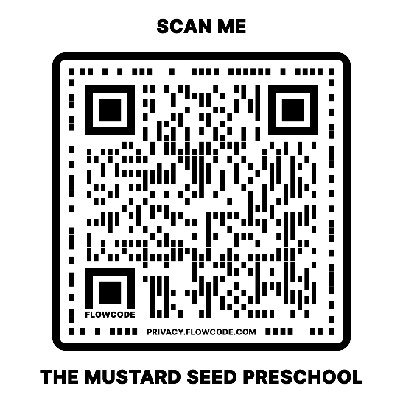
Director: Courtney Rzeplinski
848-290-2228 – Preschool Office
stpaulsmustardseedpreschool@gmail.com

www.stpaulsmustardseedpreschool.com

